Scott Fenton

Homework 3

1. a. (πsid,pidCatalog) / (πpidParts)

b.

3. a.

|  |  |  |  |  |
| --- | --- | --- | --- | --- |
| Relationship | N-1 or N-N | If N-1, name of relationship table and corrected PK for it | If N-1, table to add column to FK to, to avoid relationship table, and what column to add | If N-1, FK constraint to add to that |
| Work_in | N-N |  |  |  |
| Manages | N-1 | Manages: PK should be (pid) | Project, new column manager | FK(manager) references professor |
| Work_dept | N-N |  |  |  |
| Runs | N-1 | Runs: PK should be (dno) | Dept, new column runs | FK(Runs) references Professor |
| Major | N-1 | (no relationship table specified) | Graduates has column major | FK(major) references Depts |
| Work_proj | N-N |  |  |  |
| Advisor | N-1 | Advisor: PK should be (ssn) | Graduate, new column advisor | FK(Advisor) references Graduate |

b.  In relationship Manages, determine what is allowed by the two-column PK on the relationship table (as in the 3.13 solution) that is disallowed by the single-column PK on the relationship table. Specifically, which of the following is disallowed:

i. Two professors managing a certain project is **disallowed**.

ii. Two projects managed by one professor is **allowed**.

c. From the E-R diagram alone, we can tell that the Manages relationship is “each project has at most one manager” because there is a key constraint that is “to-one” that specifies that each project can have at most one manager. There is a partial line between Manages and Professors, which means not all professors are managers.

d. In relationship Manages, explain what is meant by the thick line from project to Manages. Specifically, which of the following is meant:

i. Every professor manages some project. This is untrue, because the line from Manages to professors is partial. This means that not every professor is a manager of a project. This is **not** meant by the thick line.

ii. Every project has a manager (a professor). The bold line from Project to Managers means that each project must have a manager, and the key constraint means that there must be at most one manager of a project. This is what is meant by the thick line.

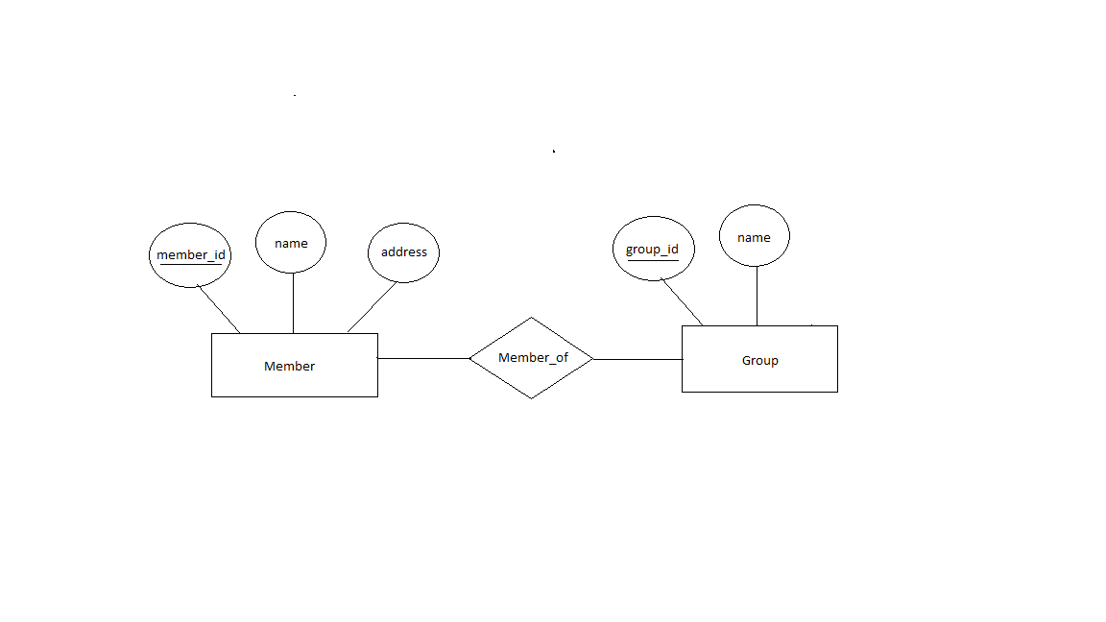

4. E-R Diagram:

Organization:

5. A. My development system OS is Windows 10.

c. I already had a Java installation on my computer.

d. My java version is 8. My javac -version is “javac 1.8.0_131”.

6. a. We can change the tables in created.sql to match these specifications by